Java – Batch Execution & Monitoring

JBEAM User Guide-

Product Development

Document Version: and Date:

By

Shantanu.Charpe@mastek.com

Table of contents

JBEAM User Guide-5.5.0 1

Table of contents 2

Table of figures 3

1. Overview 8

2. Pre-Requisites 8

3. Functions / Modules 9

4. Login Screen 10

5. Server Configuration 11

6. Home screen 16

7. View Batch 23

8. RUN Batch 33

10. View Schedules 43

11. Define Calendar 46

12. Search Batch Module 48

13. Reports/ Process 51

14. Manage user 57

15. Password Management 64

16. User Profile 68

17. References 70

18. Glossary of Terms 70

19. Business Cycle 70

20. TEMPLATE AMENDMENT HISTORY 70

Table of figures

Figure 1 Login Screen 10

Figure 2 Server Configuration 11

Figure 3 Upload Server 12

Figure 4 Add Server 13

Figure 5 Server List 14

Figure 6 Update Server details 15

Figure 7 Home Screen Pods View 16

Figure 8 Home Screen List View 17

Figure 9 Failed Objects Window 19

Figure 10 Batch Object Details 20

Figure 11 Installation pod with running Batch (Maximized) 21

Figure 12 View Batch Screen with completed batch 23

Figure 13 View Batch Screen with Batch Summary and System Information 25

Figure 14 Object Execution Graph (Maximized) 26

Figure 15 Batch Revision pod (Maximized) 27

Figure 16 Listener Details Window 29

Figure 17 Per Scan Execution Count Graph (Maximized) 30

Figure 18 Menu 31

Figure 19 Run Batch Screen 33

Figure 20 META_DATA Table snap 36

Figure 21 Home Screen and the message after submitting a request to run batch 38

Figure 22 Home Screen Pod View with current batch being loaded 39

Figure 23 Schedule Batch with recurrence 40

Figure 24 View Schedule Screen 43

Figure 25 Non-active schedules 44

Figure 26 End Reason popup 45

Figure 27 Successful cancellation message 45

Figure 28 Define Calendar Screen 46

Figure 29 Search Batch Screen 48

Figure 30 Search Batch Screen with Search result 50

Figure 31 Reports Screen 51

Figure 32 Execute Report panel on Reports Screen 52

Figure 33 Schedule Panel 54

Figure 34 Manage User Screen 57

Figure 35 Create/ Edit User Section in Manage User Screen 59

Figure 36 Tree view section in Manage User Screen 62

Figure 37 Manage User Screen with a user selected 63

Figure 38 Change Password 64

Figure 39 Forgot Password Step -1 65

Figure 40 Forgot Password Step -2 66

Figure 41 Alert message if the security question is not set 66

Figure 42 Alert Message Window 67

Figure 43 User Profile Panel 68

Document Information

|  |  |
| --- | --- |
| Document Name: |  |

Document Revision History:

|  |  |  |  |  |  |
| --- | --- | --- | --- | --- | --- |
| Sr. No. | Version | Release Date | Author | Reviewer | Reason for change |
| **1** | **5.0.5** | **04/02/2013** | **Mandar Vaidya** | **Kedar Raybagkar** | **The screen shots wherever they have remained same as in 3.2 have not been changed.** |
| **2** | **5.0.6** | **19/03/2013** | **Mandar Vaidya** | **Kedar Raybagkar** | **The screen shots wherever they have remained same as in 3.2 /5.0.5 have not been changed.** |
| **3** | **5.0.7** | **10/05/2013** | **Mandar Vaidya** | **Kedar Raybagkar** | **The screen shots wherever they have remained same as in 3.2 /5.0.5 have not been changed.** |
| **4** | **5.1.2** | **21/09/2013** | **Mandar Vaidya** | **Kedar Raybagkar** | **The screen shots wherever they have remained same as in 3.2 /5.0.5 have not been changed.** |
| 5 | **5.3.0** | **08/10/2013** | **Mandar Vaidya** | **Kedar Raybagkar** |  |
| 6 | **5.4.0** | **27/03/2014** | **Shantanu Charpe** | **Kedar Raybagkar** |  |
| 7 | **5.5.0** | **06/08/2014** | **Shantanu Charpe** | **Kedar Raybagkar** |  |

Document Revision Compatibility History:

|  |  |  |  |  |
| --- | --- | --- | --- | --- |
| Sr. No. | Version | Release Date | Monitor-Services Version | JBEAM UI |
| **1** | **5.0.5** | **25/01/2012** | **5.0.5** | **5.0.5** |
| **2** | **5.0.6** | **19/03/2013** | **5.0.6** | **5.0.6** |
| **3** | **5.0.7** | **10/05/2013** | **5.0.7** | **5.0.7** |
| **4** | **5.1.2** | **21/09/2013** | **5.1.2** | **5.1.2** |
| **5** | **5.3.0** | **08/10/2013** | **5.3.0** | **5.3.0** |
| **6** | **5.4.0** | **27/03/2014** | **5.4.0** | **5.4.0** |
| **7** | **5.5.0** | **06/08/2014** | **5.5.0** | **5.5.0** |

# Overview

The purpose of this document is to give overview of Java Batch Execution and Monitoring User Interface (JBEAM UI). The document explains how to use JBEAM UI (desktop application) with the help of screen shots and its usage.

# Pre-Requisites

While running JBEAM application following is essential:

1. Windows Desktop is required.
2. Recommended screen resolution is of 1024 x 768.
3. The desktop time must match with the server date and time with locale difference. Where server means any server where the JBEAM core is installed and configured. Example: If the JBEAM UI is installed on a desktop windows machine in India and the CORE is installed in USA whose time zone is Eastern then the time on the desktop in India must match that of USA server with the locale difference of GMT +5:30.
4. JBEAM UI is installed and ready for use.
5. The Web service component (Monitor-Services) is installed and running. The IP address and port of the server on which the web service component is installed is configured in CONFIGURATION table of bpms_monitor schema.
6. To configure multiple services, modify the CSV file embedded below to suite your configurations and then upload the same through the screen.



# Functions / Modules

JBEAM UI provides interface to operate and monitor a batch execution. The JBEAM UI is a desktop application. It has been created using Adobe AIR.

The functions in JBEAM are explained in below sections

* Login Screen
* Server Configuration
* Home Screen
* View Batch
* Run Batch
* View Schedules
* Reports
* Manage User
* Password Management
* User Profile

# Login Screen

The login screen looks as given below. The configure server link helps to add new servers as published by the service provider. The server configuration is explained in section **Server Configuration**.

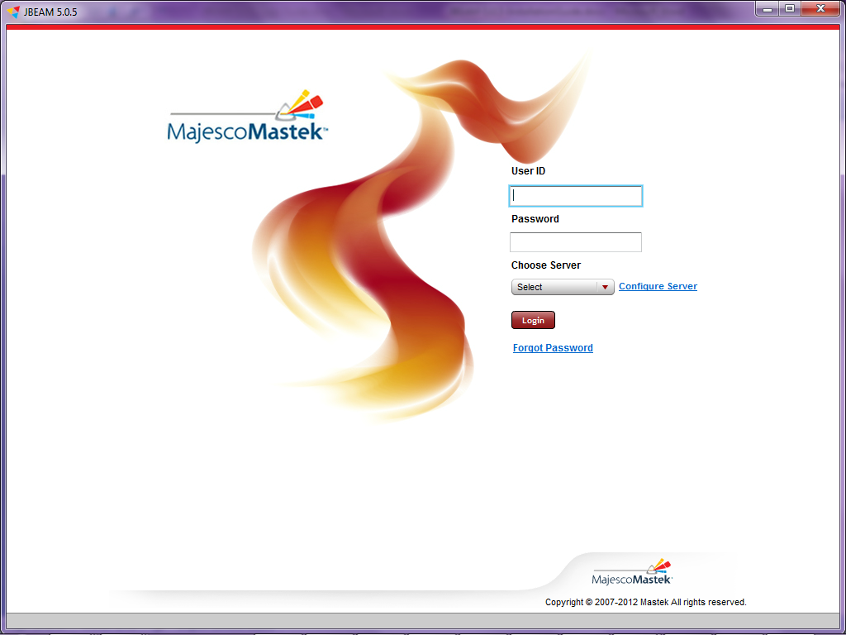

To login into JBEAM,

* 1. Enter user id, password.
  2. Choose the server.
  3. Click on ‘Login’ button.

After login, the next screen will be Home Screen.

Figure 1 Login Screen

# Server Configuration

This screen facilitates to configure server. There are two options namely Upload Server and Add server to do it. The configured servers are displayed in Server List.

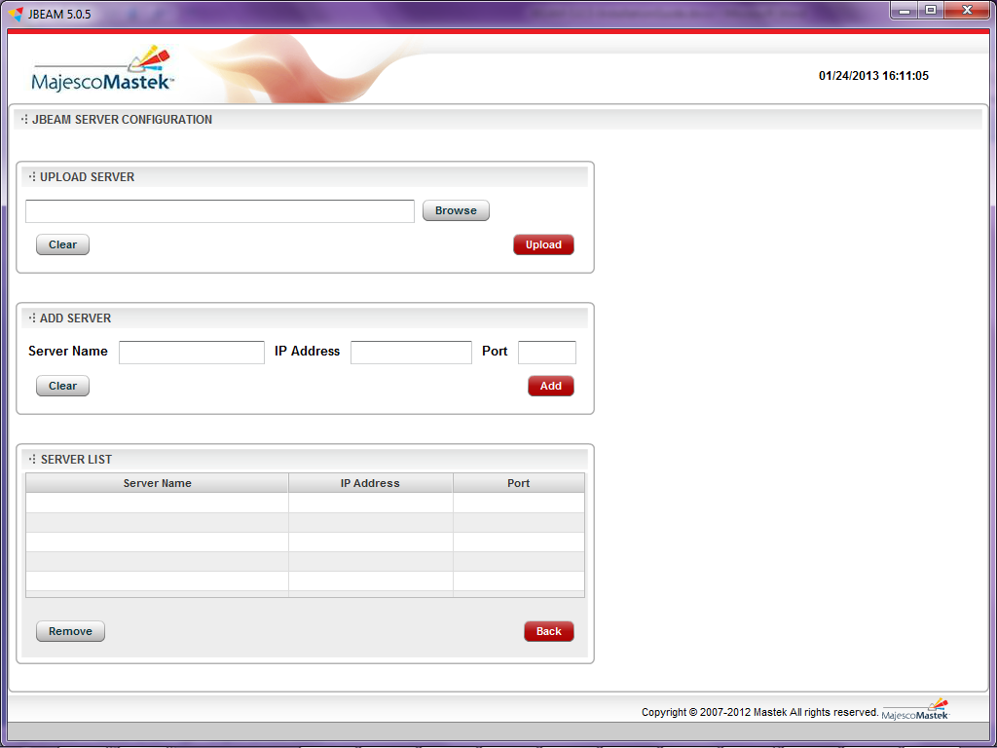

Figure 2 Server Configuration

Upload Server

To configure multiple servers, use ‘Upload Server’. To upload the data, use .csv files only.

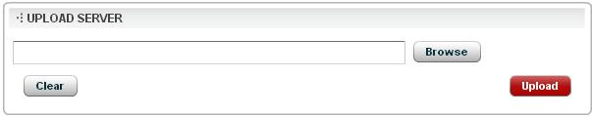

Figure 3 Upload Server

Following are the steps:

1. Click on ‘Browse’.
2. Select a CSV file (in which server data is stored) from file path.
3. Click on ‘Upload’.
4. The servers can be viewed in Server List
5. On successful configuration of server, click on ‘Back’ button to go back to Login screen.

Add Server

To configure a single server, use ‘Add Server’

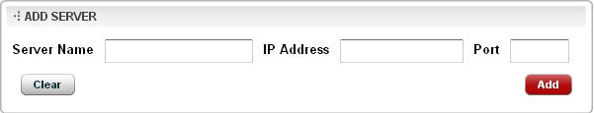

Figure 4 Add Server

Following are the steps:

1. Enter valid server name.
2. Enter valid IP Address.
3. Enter valid port number. It should be numeric.
4. Click on ‘Add’.
5. On successful configuration of server, click on ‘Back’ button to go back to Login screen.

Server list

The configured servers are displayed in the server list.

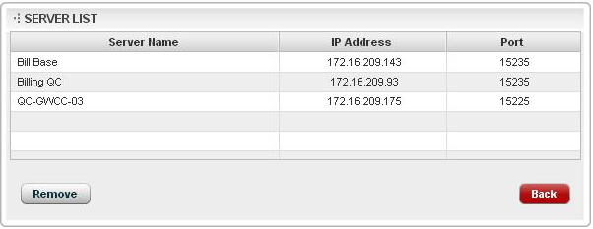

Figure 5 Server List

Update Server details

The configured server details like IP address and port can be updated.

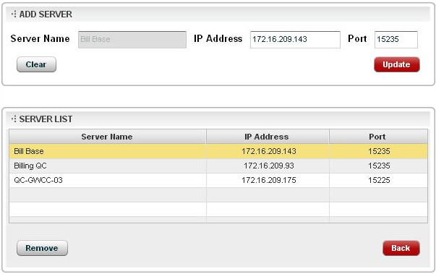

Figure 6 Update Server details

Following are the steps:

1. Select the desired server from the server list.
2. The selected server details are populated in Add Server section.
3. Update the desired details such as IP address and port.
4. Click on ‘Update’. This updates the server list with the appropriate changes.
5. Click on ‘Back’ button to go back to Login screen.

# Home screen

The home screen displays all the configured installations, to which the user has an access to view, along with their last executed batch details. There are two views for home screen namely ‘POD VIEW’ and ‘LIST VIEW’. The default home screen is ‘POD VIEW’, which shows installations in pod format as shown below:

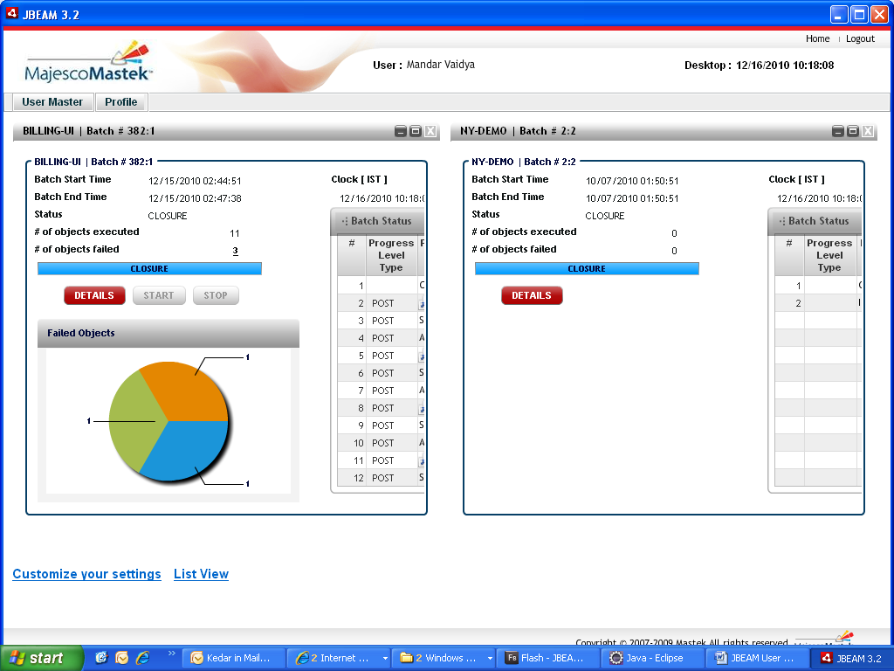

Figure 7 Home Screen Pods View

***Note:*** *The user can set the default view in the user profile. Once logged in, the default view can be switched between the POD/LIST VIEW.*

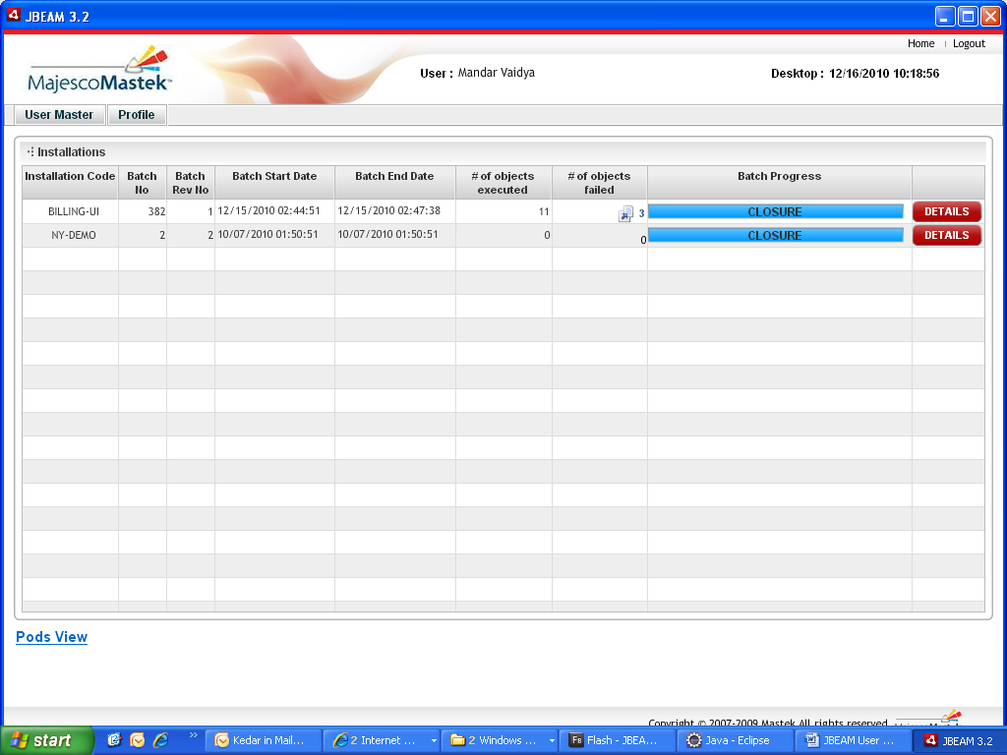

Figure 8 Home Screen List View

The home screen has features like view batch details, start/resume or stop batch for each installation. The links for Home and Logout on the top right corner provide the facility to navigate to home page and log out from the system respectively. The home link also refreshes the data displayed on the home screen.

In POD VIEW, the position of a pod can be changed by dragging and releasing it to a new position. One can maximise, minimise or close a pod. To close any pod(s), click on the top right corner ‘X’ button to close. These features of the pod are applicable to all the pods across the system. To restore a pod after closure, click on ‘Customize your Settings’ link. A pop up will show the list of closed pod(s) or non-opened pod(s) (if any). Check the pod(s) and click on ‘Submit’ to restore the respective pod(s). To minimise any pod or pods, click on the top right corner ‘-’ button. The minimised pod are stored just above the ‘Customize your Settings’ link. To restore a minimised pod, user can double click on the pod(s).

Every installation / pod will have information like:

* The installation code, batch number and batch revision number.
* Batch Start time
* Batch End time
* Current batch status
* Number Of objects executed
* Number Of objects failed
* Batch Status table

The statistics are collected every 5 seconds. Failed objects count is displayed as a link provided there are 1 or more failed objects. On click, a new popup window displays the details of the failed objects as shown in Figure 9 Failed Objects Window.

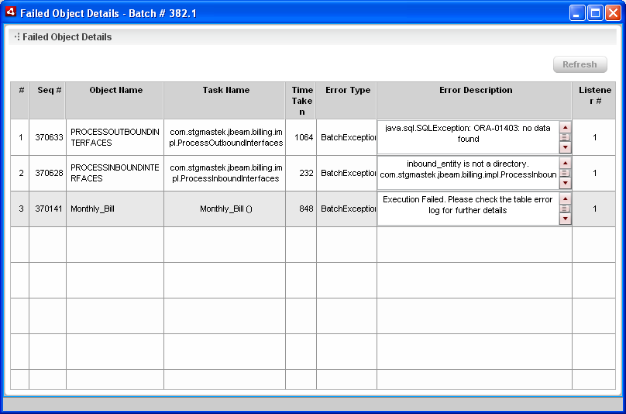

Figure 9 Failed Objects Window

The Batch Status table displays the execution steps as carried out by JBEAM Core in descending order. A link appears on the activity type ‘Execution’. On click, a new popup displays the details of the batch objects executed as shown in Figure 10 Batch Object Details.

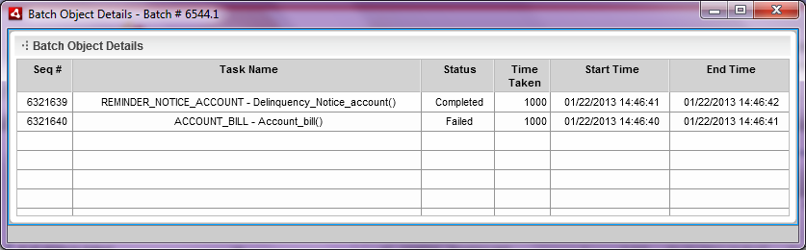

Figure 10 Batch Object Details

When a batch is in progress, the installation pod looks as below:

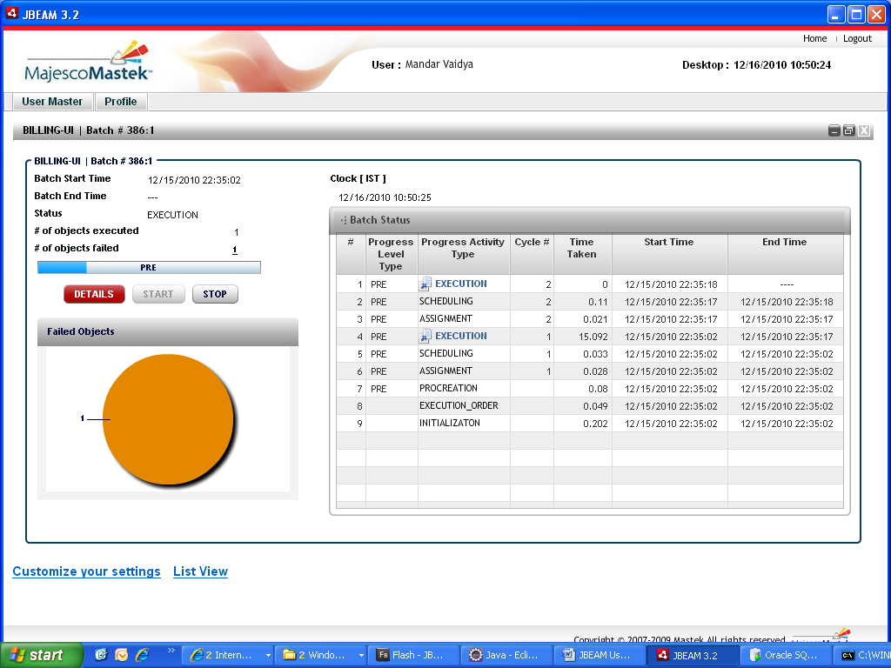

Figure 11 Installation pod with running Batch (Maximized)

In POD VIEW, following buttons are provided:

|  |  |  |  |  |
| --- | --- | --- | --- | --- |
| **Button** | **Functionality** | **Conditions** | | **Visibility** |
| **Enabled (Activated)** | **Disabled (Deactivated)** |  |
| **DETAILS** | To view details of the batch (navigates to batch details screen). Also to navigate to other menus like Run Batch. | 1. Batch is running 2. Batch is stopped / completed | 1. Fresh installation (No batch details available) | Visible to users with USER/ OPERATOR role |
| **START/ RESUME** | To start/ resume a batch | 1. Fresh installation (No batch details available). (START) 2. Batch is stopped (RESUME) | 1. Batch is running 2. Batch is completed | Visible to users with OPERATOR role only |
| **STOP** | To stop a currently running batch process. A request will be sent to the server and the server will respond with an alert on the screen | 1. Batch is running | 1. Fresh installation (No batch details available) 2. Batch is stopped / completed. | Visible to users with OPERATOR role only |

In LIST VIEW, the button DETAILS is available on home screen and the RESUME/ STOP are available in Batch Summary Pod.

***Note:*** *For a fresh installation the button START will be enabled. On click, the Run Batch screen appears.*

# View Batch

This screen is brought forward on the click of the ‘DETAILS’ button of the installation pod / installation list. The view batch screen is further divided into 5 sub pods. Out of these, two are static namely Batch summary and System Information and three are dynamic namely Batch Revision, Object Execution Graph and Per Scan Execution Count Graph.

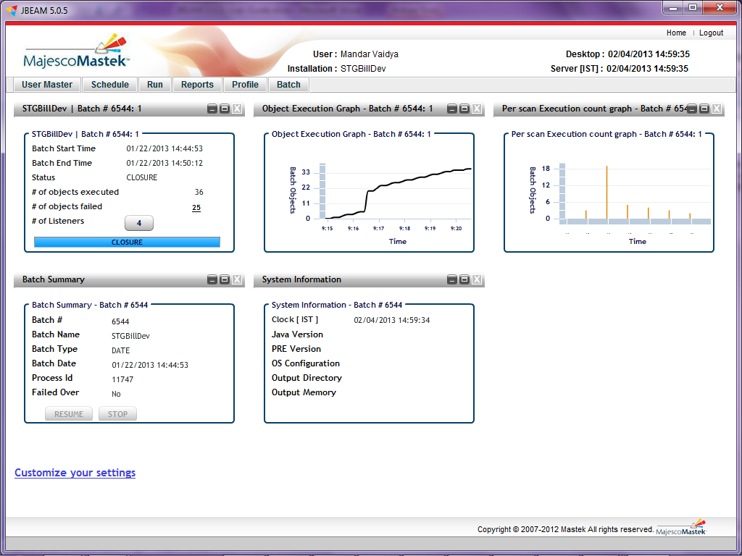

Figure 12 View Batch Screen with completed batch

The Batch Summary pod shows:

* The batch number
* Name of the batch (if any )
* Type of the batch i.e. special or date run
* Batch Start Date
* Batch Process Id which is generated by the server
* Failed Over Status (Yes/No)
* Batch Parameters list (provide while running SPECIAL batch)

This pod contains the buttons to RESUME or STOP a batch. The buttons have the same functionality as provided on home screen (POD VIEW).

While the batch is running, the STOP button will be enabled. If the batch is stopped, the RESUME button will be enabled. When a batch is in completed, both the buttons will be disabled (as shown in Figure 13 View Batch Screen with Batch Summary and System Information).

* If the type of batch is SPECIAL, then only the Batch Parameters can be seen.

System Information pod displays the technical details as following:

* Java Version installed on the server
* PRE Version for running the batch
* The System Configuration of the server where the batch is processed
* Directory Path for the output
* Free memory available on the directory path for the output

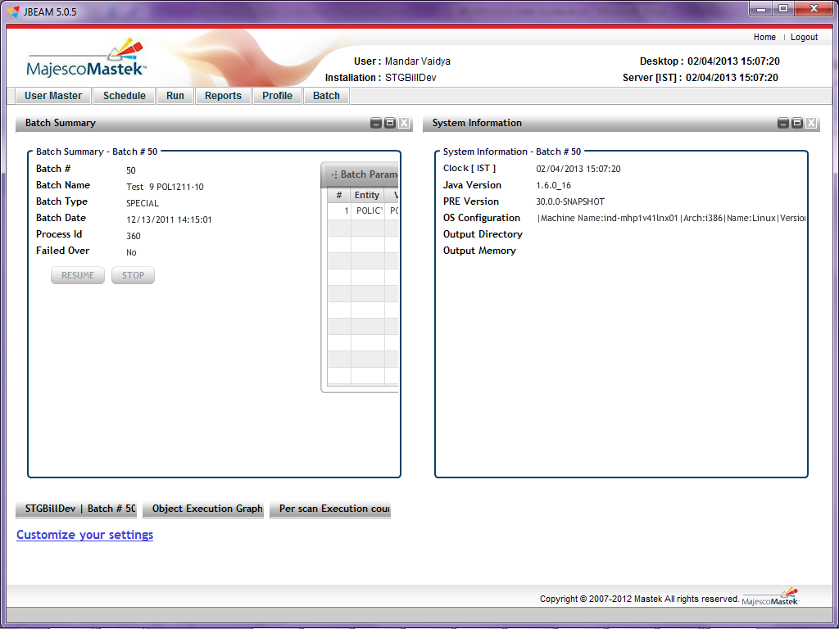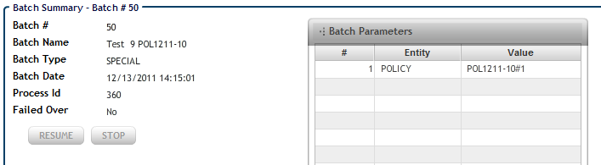

Figure 13 View Batch Screen with Batch Summary and System Information

The three dynamic pods namely Batch Revision, Object Execution Graph and Per Scan Execution Count Graph are tied with a batch revision and will increase as per the number of batch revisions. If there is only one batch revision, then there will be 3 dynamic pods. If there are two batch revisions, then there will be 6 dynamic pods and so on. System will display the pods associated with latest revision. More details are as following:

Object Execution Graph Pod

The Object Execution Graph is a line graph for batch objects against time elapsed for the object execution. The batch objects are on Y axis and time elapsed is on X Axis. When batch is in progress, the graph is refreshed after every 5 sec. For closed batch revisions or a closed batch, the graph can be seen any time. To view the data for a particular point on a graph, move the cursor over the tip. . This graph always displays the last 100 records.

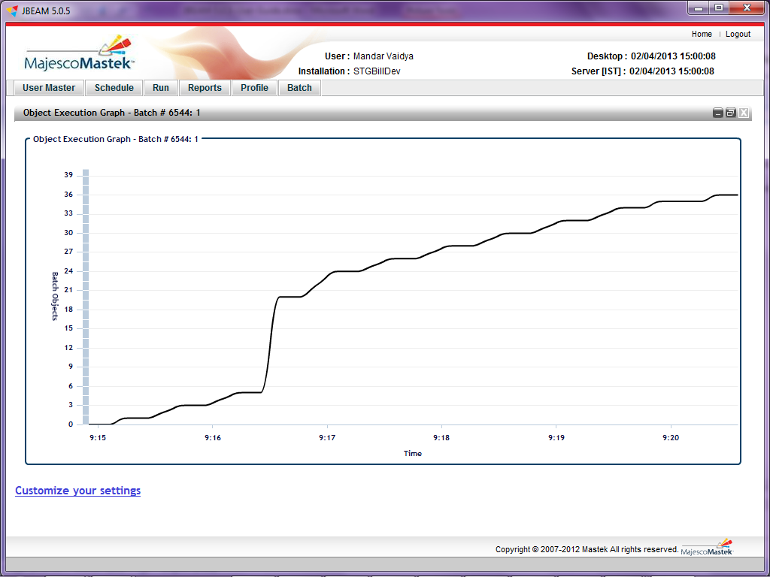

Figure 14 Object Execution Graph (Maximized)

Batch Revision Pod

The batch revision pod once maximized shows details about the execution order. The following screen displays the Batch Revision pod in a maximized form.

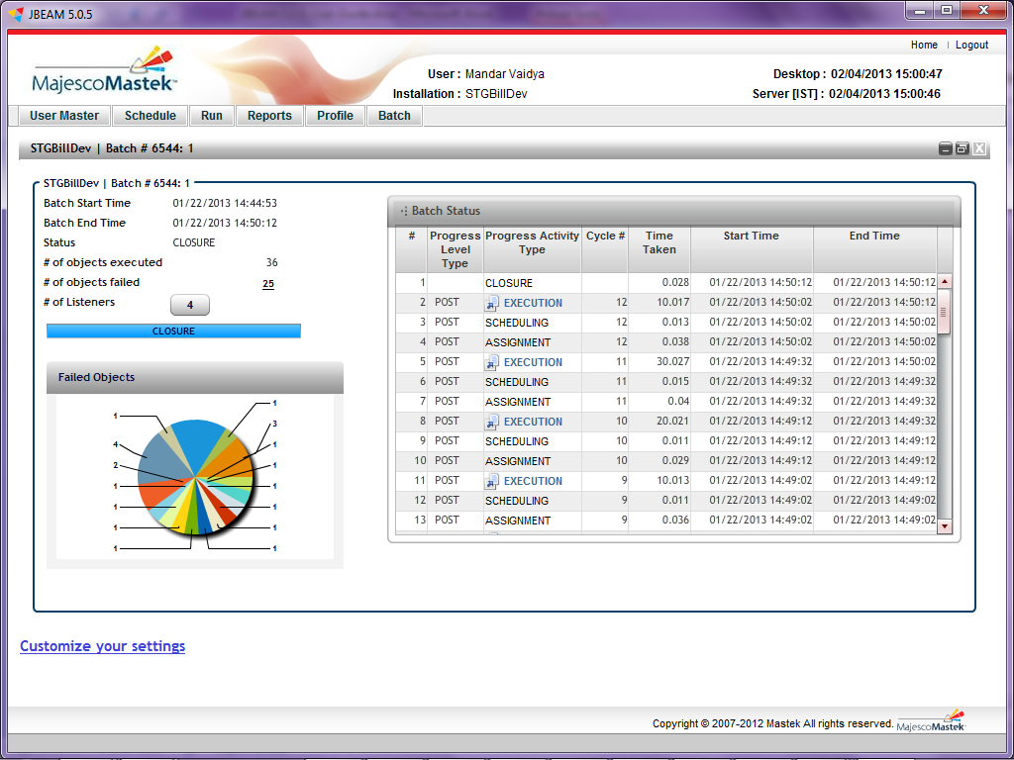

Figure 15 Batch Revision pod (Maximized)

Every batch revision pod will have statistics like:

* The batch number and batch revision number.
* Batch Start time
* Batch End time
* Batch status
* Number Of objects executed
* Number Of objects failed
* Number Of listeners
* Time Taken / Time Elapsed
* Batch Status table

The statistics are collected every 5 seconds. The details are displayed same as installation pod except the Number (#) of listeners. The Listener count is displayed as button. While a batch is running, the button colour remains red and on completion of the batch, it becomes white. On click, it opens a new popup window and displays the details of listeners as shown in below given figure. The details again include the number of failed objects for each listener spawn while execution of batch. To view details of failed objects for a listener, click on the desired row.

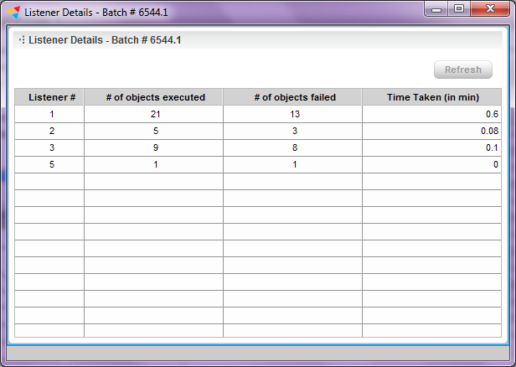

Figure 16 Listener Details Window

The Batch Status table displays the execution steps as carried out by JBEAM Core in descending order. A link appears on the activity type ‘Execution’. On click, a new popup window will open to display the details of the batch objects executed as shown in Figure 10 Batch Object Details.Per Scan Execution Count Graph Pod

The Per Scan Execution Count Graph is a column graph for batch objects per scan against the time elapsed. The batch objects per scan are on Y-Axis and the time elapsed is on X-Axis. When batch is in progress, the graph is refreshed after every 5 sec. For closed batch revisions or a closed batch, the graph can be seen any time. To view the data for a particular point on a graph, move the cursor over the tip

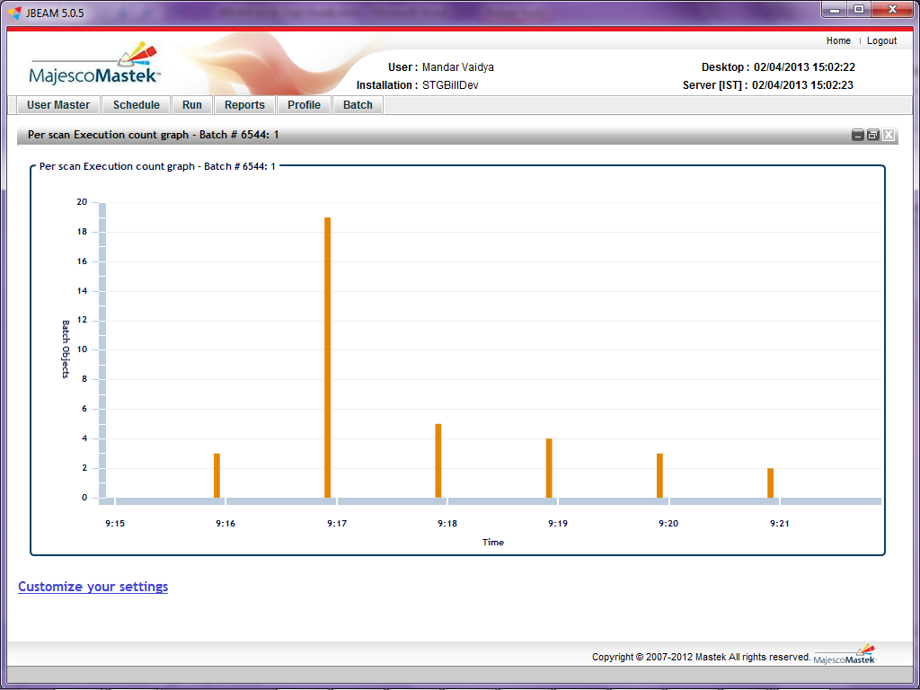

Figure 17 Per Scan Execution Count Graph (Maximized)

Menu

The BATCH Details screen displays total 6 menu items (provided the logged in user have ADMIN rights).



Figure 18 Menu

For ADMIN

* + - 1. USER MASTER
         1. Manage User

For OPERATOR

* + - 1. Schedule
         1. View Schedule
      2. Run
         1. Run Batch
         2. Define Calendar

For USER

* + - 1. Reports
         1. Generate Reports
      2. Batch
         1. Search
         2. Current
      3. Profile
         1. Change Password
         2. Edit Profile

# RUN Batch

This screen facilitates to execute the batch either DATE (without parameters) or SPECIAL (with some parameters). It also facilitates to schedule a batch with associating recurrence factor.

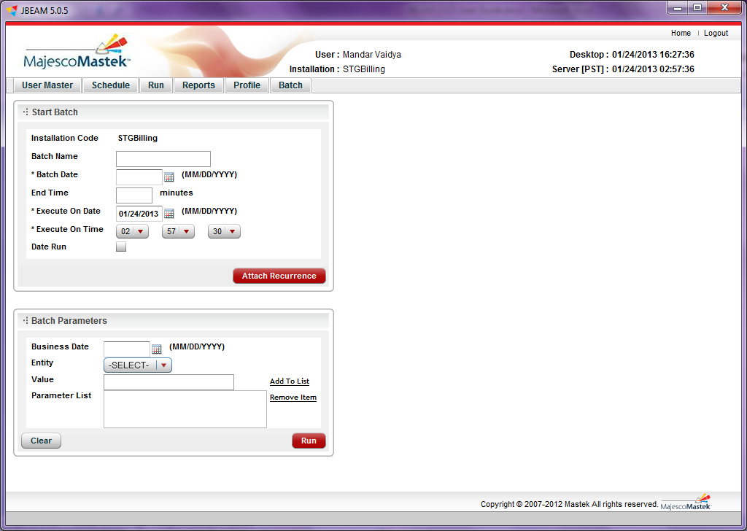

Figure 19 Run Batch Screen

This screen has been divided into two main parts:

* Start Batch Section

This screen accepts batch name, batch date, End Time, batch type (Special/ Date run) as explained below.

* Installation code

This will be populated by system, depending upon the installation selected (for which the user wants to run a batch).

* Batch name

This can be any logical name for the batch.

* Batch date

This is the only mandatory field (unless the button ‘Attach Recurrence’ is clicked).

* End Time (Time in minutes)

This is optional. Indicate the batch to stop after *n* minutes. The batch arrives at a logical completion and may not necessarily stop at the said time provided a logical completion is not arrived.

* Date Run (Check box)

To be selected if the all the jobs scheduled for the date are to be executed. Once checked, the Batch Parameter block will be disabled.

To schedule a batch with a recurrence one can click on the ‘Attach Recurrence’ button which is optional. This button will open a new block for recurrence. Please refer to Recurrence section for more details.

* Batch Parameters section

The batch parameters are needed only the execution is of a special type. The execution of the batch will be limited to the given parameters. The following indicates what different types of parameters can be passed to the batch executor.

|  |  |
| --- | --- |
| **Entity** | **Value** |
| **PRE** | Batch will be executed for the given pre event. (Priority code from META_DATA table of CORE schema) |
| **POLICY** | Provide the policy number or numbers for which the batch needs to be executed. |
| **ACCOUNT** | Provide the account number or numbers for which the batch needs to be executed. |
| **BROKER** | Provide the broker (agent) code or codes for which the batch needs to be executed. |
| **GENERAL** | Provide the general data other than policy, account, agent/ broker for which the batch needs to be executed. |
| **POST** | Batch will be executed for the given post event. (Priority code from META_DATA table of CORE schema) |

All these entities are configured in COLUMN_MAP of both schema (CORE and MOPNITOR). The PRE and POST objects are listed in META_DATA table of CORE schema with priority code.

This section is active if the Date Run check box is not selected in above section and following are the required entries.

* Business Date

This date is

* Entity

As described above, select an entity from the dropdown box. The entities are populated by system, depending upon the installation selected and data in COLUMN_MAP table of MONITOR schema.

* Value

This field requires the value for which the batch is required to run. It should be always valid and selected from the BATCH_EXECUTOR table of application schema. Enter the appropriate value in this field and click on the link ‘Add to list’. The combination is added to Batch Parameters list.

e.g. Entity: POLICY

Value: POL_01

Batch Parameter: POLICY= POL_01

The table given above describes the valid combinations of PRE or POST objects. And following figure shows the snapshot of the META_DATA table.

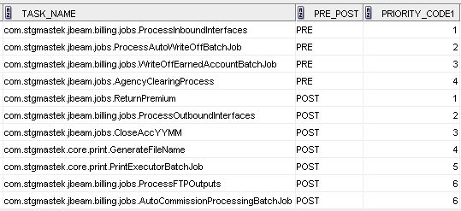

Figure 20 META_DATA Table snap

***Note:*** *This may vary from installation to installation and is referenced here for explanation purpose.*

* Parameter List

User can view the added entity and values in this box. If user wants to remove an entity/ value pair from the list for whatsoever reason, he can select that / those entries and click on Remove Item link.

Following is an example with the valid data for a batch

|  |  |  |  |
| --- | --- | --- | --- |
| **Parameters** | **Value** | | |
| Batch Name (Optional) | Batch 101 | | |
| Batch run date (Mandatory) | 25/01/2013 (The time 23:59:59 will be default) | | |
| End On (Optional) | --- | | |
| Execute On Date(Mandatory) | 25/01/2013 (The System date in database) | | |
| Execute On Time(Mandatory) | 00:00:00 (The System time in database, check once) | | |
| Business Date(Optional) | 25/01/2013 | | |
| Entity | PRE | POLICY | POST |
| Value | ALL | POL-01 | ALL |

To run a batch without schedule, user can click on ‘Run’ button. On successful submission of request, the system will be redirected to Home page as shown below in Figure 21.

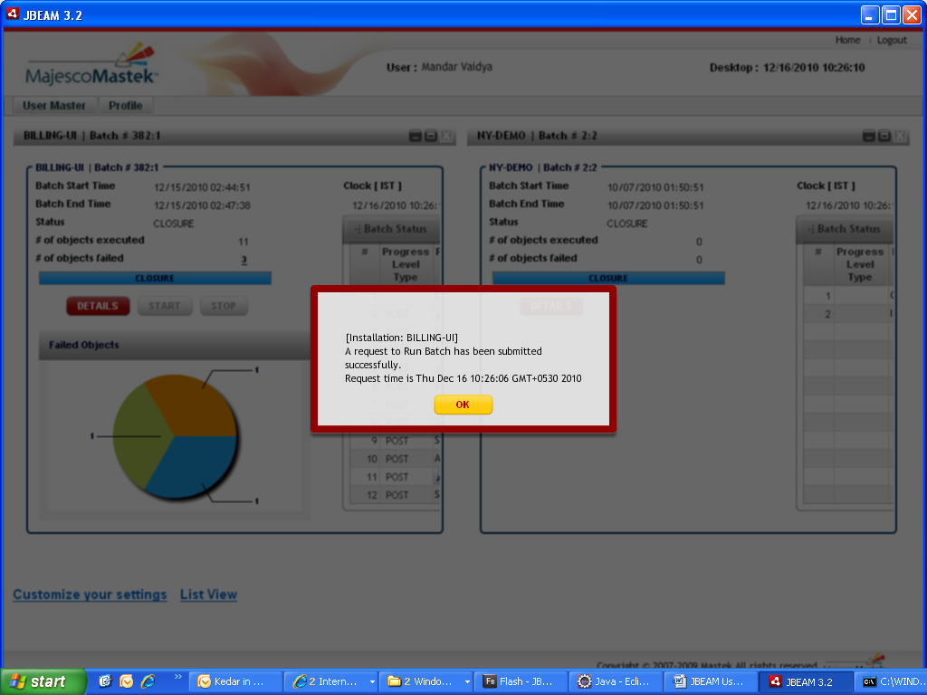

Figure 21 Home Screen and the message after submitting a request to run batch

Once the request is sent to PRE, the data related to last batch on the screen is cleared and the message is displayed as shown in Figure 22

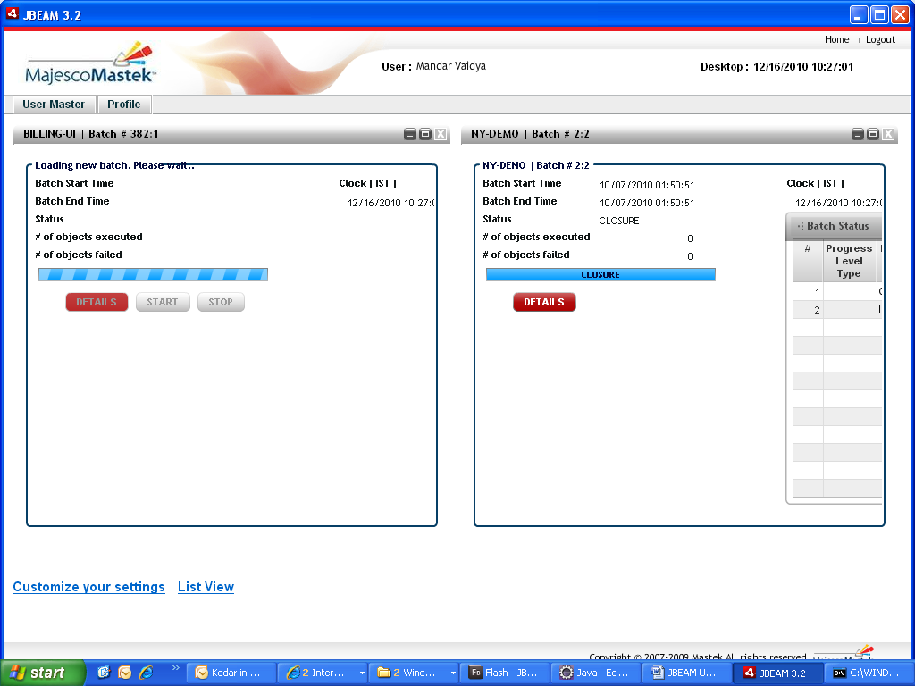

Figure 22 Home Screen Pod View with current batch being loaded

* Recurrence

This section of the screen is to be used only if the user wants to schedule the batch in an auto recurrence mode.

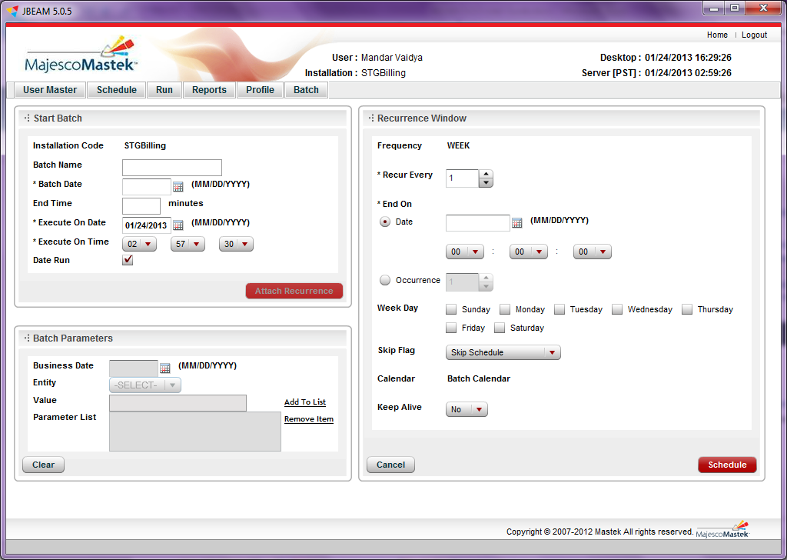

Figure 23 Schedule Batch with recurrence

* Frequency

As the batch runs on a Sunday through Thursday basis the frequency is hardcoded to a week.

* Recur Every:

The user can define the recurrence factor such as recur every one week/two weeks, etc. In a regular scenario the recurrence factor will be to recur every 1 week.

* End on date or end occurrences:

End On Date defines the end time of the schedule. End On Date should be used if it is difficult to calculate the number of occurrences.

* Week day

All the Weekdays are displayed with a checkbox. While scheduling a batch, check the desired day/s. Specify days in the week on which, the batch must be executed.

* Skip flag

This has to be used in case the schedule is to be associated with a non-working calendar. Skip flag identifies if the schedule should check for pre-programmed Calendar or a Weekday check. The valid values and description are as follows:

|  |  |
| --- | --- |
| **Value** | **Description** |
| **NA** | Indicates that there is no skipping of the scheduled date is necessary and it is okay to accept the scheduled date as arrived by the associated frequency. Example if a Calendar frequency "MONTH" is associated and say the schedule starts on Jan 01, 2008 and recur every 1 month then the next schedule will be Feb 01, 2008 and after that it would be Mar 01, 2008. Mar 01 2008 is a Saturday. PRE will not do any checks and will schedule a JOB to be executed on Mar 01, 2008. |
| **D+** | Indicates that the schedule should be postponed by a Day. |
| **D-** | Indicates that the schedule should be advanced by a Day. |
| **SS** | Indicates that the schedule should be skipped to the next recurrence of the schedule. |

* + The default calendar that will be referred by the scheduler to identify non-working thus non-scheduling dates. This is applicable only if the skip flag does not equals Not Applicable.
  + Keep Alive

This has been introduced as a feature in the schedule. This means that even if the job returns false or throws exception then the schedule will still pro-create the job as per its frequency.

* Remember that if there is any SQL or IO exception during persistence of the pro-creation of the scheduled job then in that case the scheduler will fail to pro-create the JOB.

To schedule the batch, click on ‘Schedule’ button.

# 

# View Schedules

This screen facilitates to view schedules (Active / non-active). The user with OPERATOR role can cancel any active schedule/s. The buttons Refresh and Cancel Selected are activated for Active schedules only.

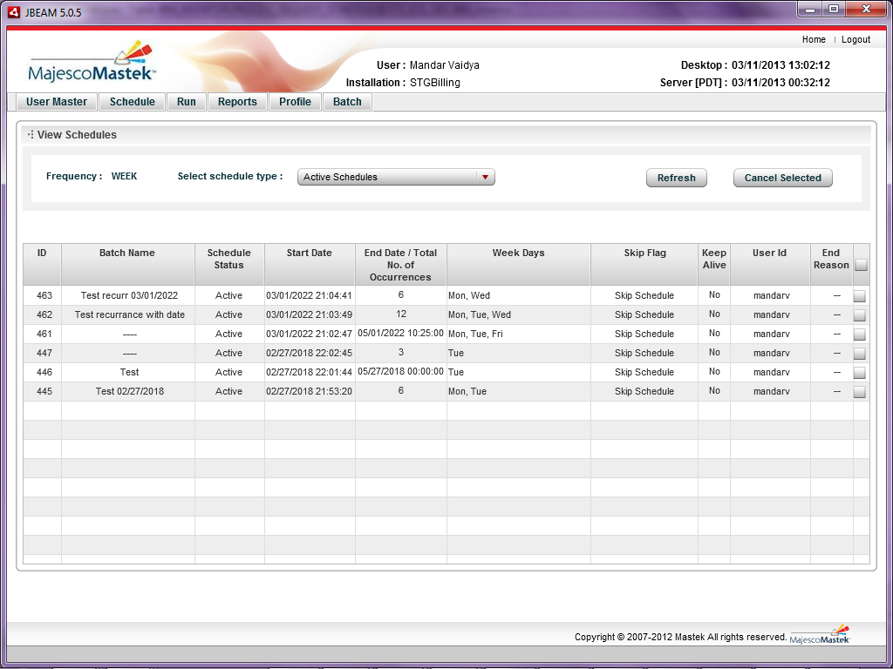

By default the frequency type is Week.

For each active schedule a checkbox is provided to select for cancellation.

To select all schedules for cancellation, user can select the checkbox given in header. Same checkbox will help to deselect all schedules.

After cancellation of a schedule, a message as shown in Figure 27 will appear on screen.

Figure 24 View Schedule Screen

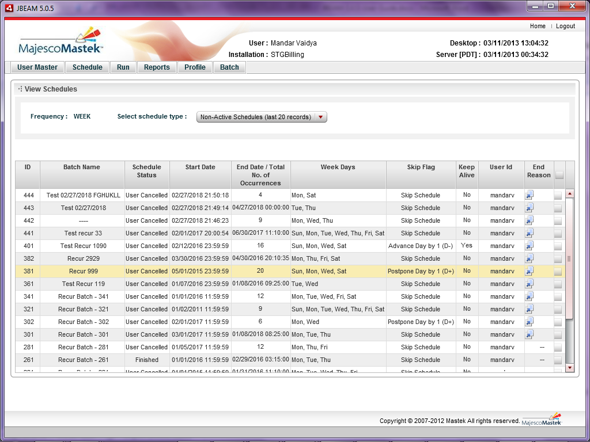

Figure 25 Non-active schedules

In Non-active schedules view, user can see last 20 records only. To view end reason user can click on the note image provided in End Reason column. It will open a window as shown in Figure 26 End Reason .

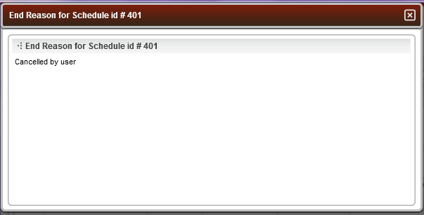

Figure 26 End Reason popup

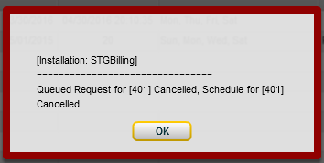

Figure 27 Successful cancellation message

# Define Calendar

The non-working days can be configured using the Define Calendar menu. 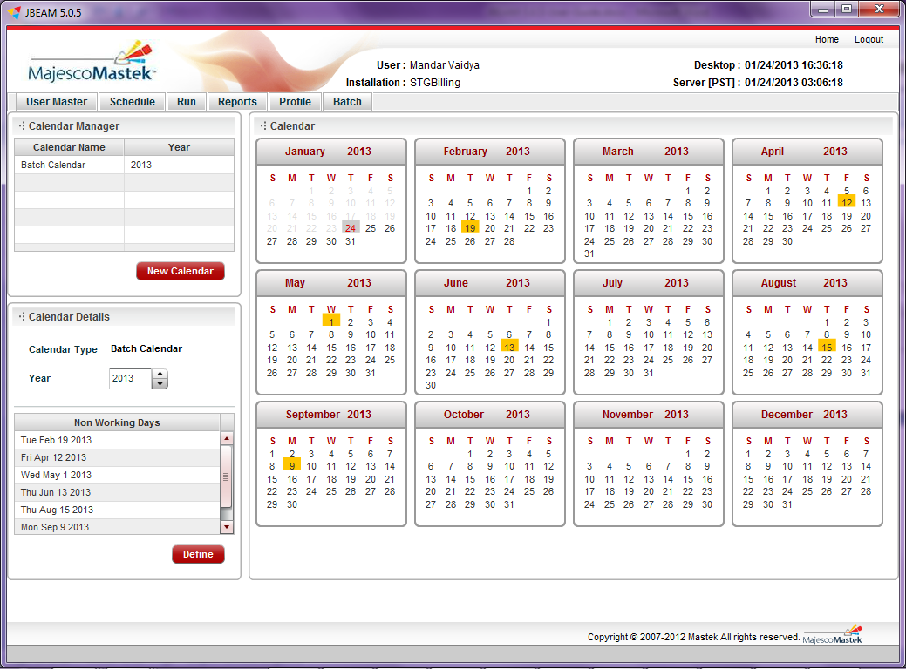

Figure 28 Define Calendar Screen

This works as follows:

The Define Calendar screen has 3 main sections:

* Calendar Manager

This section displays the defined batch calendars. Upon click of any of the list items, user can view the details of the defined calendar.

* Calendar Details

This section accepts year as the input. To define a calendar, user can click on ‘Define’ button provided there are non-working days in the table and the year is not defined earlier.

* Calendar

This section displays the Calendar for selected year. To select non working days, user can click on the date.

# Search Batch Module

This module helps user to view details of previous run batches. There are many filters to search for any previous batch.

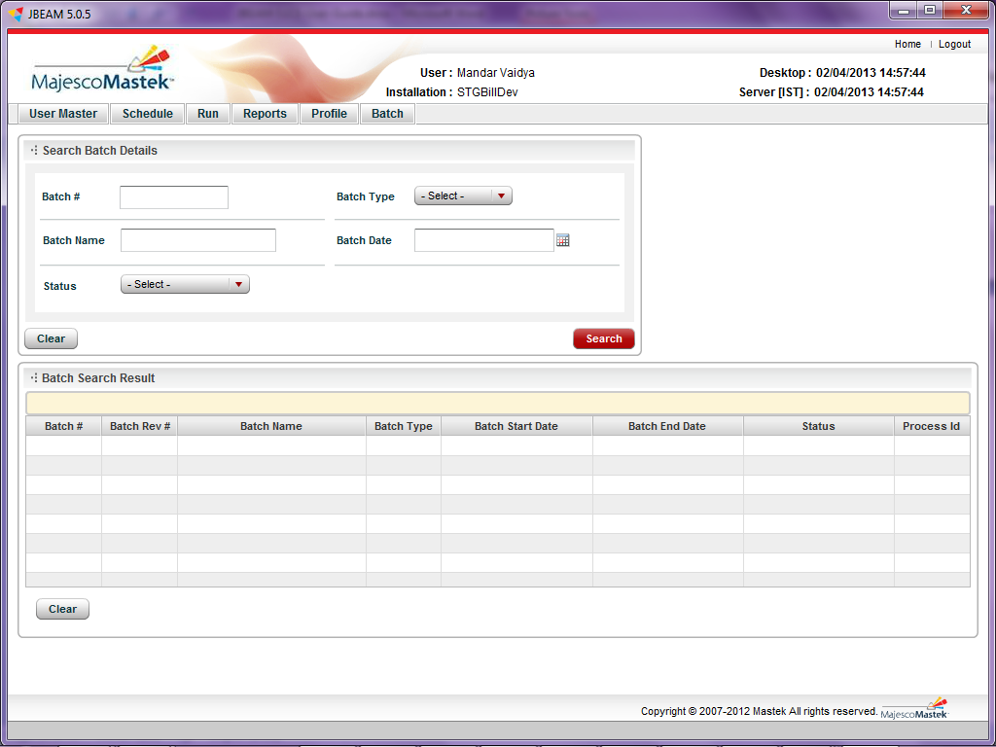

Figure 29 Search Batch Screen

|  |  |
| --- | --- |
| **Search Item** | **Description** |
| **Batch #** | Any existing batch number for the installation |
| **Batch Type** | The batch type is defined while sending request for to run batch. The valid types are DATE and SPECIAL. |
| **Batch Name** | Any character or word that seems to be possible can be entered. The system will fetch the batches for which the batch name includes the entered character / word. |
| **Batch date** | Batch Execution date |
| **Status** | Following is the list of valid batch status   * BATCH COMPLETED – Successful completion of batch * USER INTERRUPTED – A batch is stopped in between by a user (operator) * END OF TIME – If end time is mentioned while sending request to run batch * BATCH FAILED – While running a batch, if any exception comes and is configured to stop the batch then the batch status will be BATCH FAILED. * PRE ISSUED STOP – If due to any reason PRE issues a request to stop a running batch.   The records will be fetched for matching status |

To fetch all previous batch records, just click on ‘Search’ without selecting any filter. All the fetched records will be displayed in the Batch Search Result table as shown in Figure 30.



Figure 30 Search Batch Screen with Search result

# Reports/ Process

In this module user can generate various types of reports. Currently there is only one report (Purge Routine Core) that has been configured.

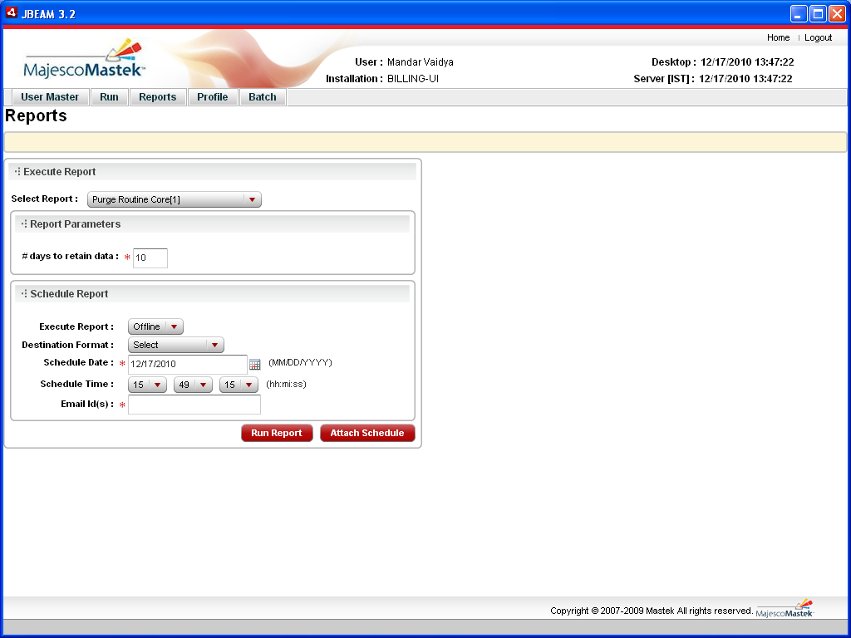

Figure 31 Reports Screen

In Execute Report section, select the desired report from the dropdown. (In this case, Purge Routine Core is the available report). For every report there can be certain parameters, which are populated automatically with the default value and validations. (In this case, the ‘# of days to retain data’ is the available parameter.

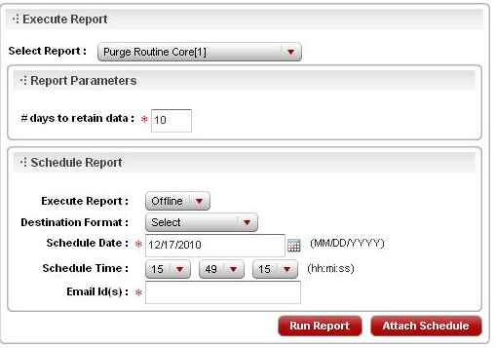

Figure 32 Execute Report panel on Reports Screen

The Schedule Report section contains the followinginput:

* Execute Report:

ONLINE / OFFLINE (In this case, only OFFLINE reports can be executed)

* Destination format:

Generate reports in following formats:

|  |
| --- |
| **Formats** |
| MS Excel (xls) |
| MS Word (doc) |
| Adobe Acrobat Reader (pdf) |
| Rich Text Format (rtf) |
| MS Power Point (ppt) |

* Schedule Date:

The date to run a report

* Schedule Time:

The time to run a report

* Email id(s):

The email id to which the notification mail needs to be sent after running a report

Schedule- Request Status Inquiry

This section of the screen facilitates to schedule the report in an auto mode.

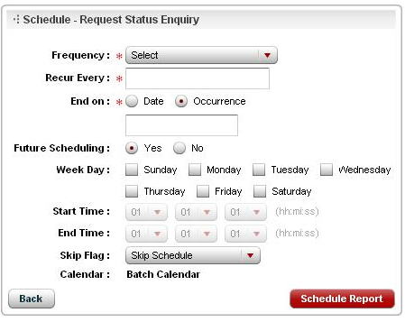

Figure 33 Schedule Panel

* Frequency

As the batch runs on a Sunday through Thursday basis the frequency is hardcoded to a week.

* Recur Every:

The user can define the recurrence factor such as recur every one week/two weeks, etc. In a regular scenario the recurrence factor will be to recur every 1 week.

* End on date or end occurrences:

End On Date defines the end time of the schedule. End On Date should be used if it is difficult to calculate the number of occurrences. The user can specify specific days in the week on which, the batch must be executed.

* Future Scheduling

Values can be ‘Yes’ or ‘No’. The default is ‘Yes’.

* Week Day

All the Weekdays are displayed with a checkbox. While scheduling a batch, check the desired day/s.

* Start time

This will be activated only if the selected frequency is day.

* End Time

This will be activated only if the selected frequency is day.

* Skip flag

This has to be used in case the schedule is to be associated with a non-working calendar. Skip flag identifies if the schedule should check for pre-programmed Calendar or a Weekday check. The valid values and description are as follows:

|  |  |
| --- | --- |
| **Value** | **Description** |
| **NA** | indicates that there is no skipping of the scheduled date is necessary and it is okay to accept the scheduled date as arrived by the associated frequency. Example if a Calendar frequency "MONTH" is associated and say the schedule starts on Jan 01, 2008 and recur every 1 month then the next schedule will be Feb 01, 2008 and after that it would be Mar 01, 2008. Mar 01 2008 is a Saturday. PRE will not do any checks and will schedule a JOB to be executed on Mar 01, 2008. |
| **D+** | indicates that the schedule should be postponed by a Day. |
| **D-** | indicates that the schedule should be advanced by a Day. |
| **SS** | Indicates that the schedule should be skipped to the next recurrence of the schedule. |

For D+ or D- or SS there must be at least a ICalendar or a Weekday Check Flag or both, otherwise the skip flag must be NA.

* + The default calendar that will be referred by the scheduler to identify non-working thus non-scheduling dates. This is applicable only if the skip flag does not equals Not Applicable.

# Manage user

This module facilitates the user management.

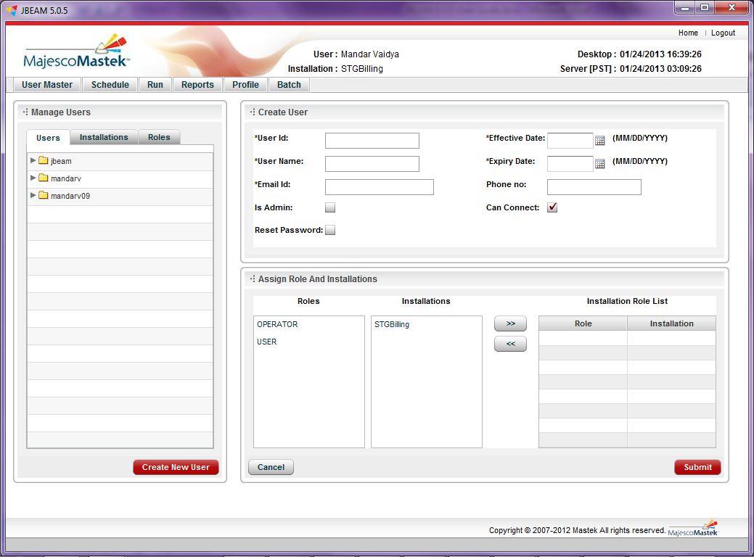

Figure 34 Manage User Screen

In order to make the UI user –role based, there are certain roles configured in JBEAM. Following are the details for these roles:

|  |  |
| --- | --- |
| **Role** | **Significance** |
| **CONNECT** | It provides access for JBEAM UI. This as well as ADMIN role are meant for the application and not for individual installations. |
| **ADMIN** | Can manage users, reset password for any user. |
| **USER** | Can view the batch processing, however may not be able to operate (run/resume/stop) batch and define calendar. |
| **OPERATOR** | Can operate (run/resume/stop) batch and define calendar. The USER role is automatically provided with this role. |

This screen is available to a user with ADMIN role only. Here the ADMIN can create a user, modify existing user, and reset the password for a user.

This screen has three main parts:

* Create/Edit User

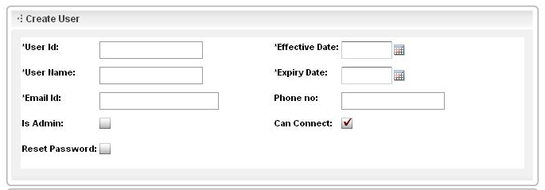

Figure 35 Create/ Edit User Section in Manage User Screen

***Note:*** *‘*’ indicates the mandatory fields.*

* Mandatory fields
* User Id

Login id of the user. Maximum length 10 characters.

* User name

Name of the user. Maximum length 50 characters.

* Email Id

A valid email id. This will be used to send login password related information. In following cases emails will be sent:

* New user created
* Reset Password by ADMIN
* Reset Password using ‘Forgot Password’ link
* Effective date

The effective date should be always less than or equal to the system date.

* Expiry date

The expiry date should be always greater than or equal to the system date.

* Optional Fields
* Phone number

Indicate the contact number.

* Is Admin (Check box)

To be selected if the new user is needs ADMIN role.

* Can Connect (Check box)

By default this is checked. This is essential for login. If unchecked, the user even though is valid, will not be allowed to login.

In JBEAM, there is no provision to delete a user. To restrict any user from accessing JBEAM UI, uncheck this check-box or change the expiry date.

* Reset Password (Check box)

Resets the password for selected user.

* Assign Role and Installations

As shown in the figure, there are 2 lists provided on LHS namely Roles and Installations. ADMIN can assign appropriate roles and installations to a user, by selecting from the list and click on ‘>>’ button. The desired combination will be displayed in the RHS table. ADMIN can remove any role-installation combination, by selecting the desired combination of role and installation and click on ‘<<’ button. While selecting or deselecting roles- installations, following should be kept in mind:

1. If OPERATOR role is assigned, the USER role is assigned automatically for the selected installation. Vice versa is not true.
2. If USER role is removed from Installation Role List (RHS table), OPERATOR role will also be remove for that installation. Vice versa is not true.

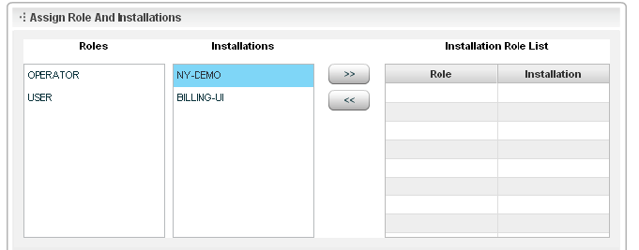

Figure 23 Assign Role and installation section in Manage User Screen

* Manage Users

The existing users can be seen on Left Hand Side (LHS). The 3 tabs display the same information with different views namely Users, Installations and Roles. To edit a user, in Users view, select parent node and in other views select respective child nodes,

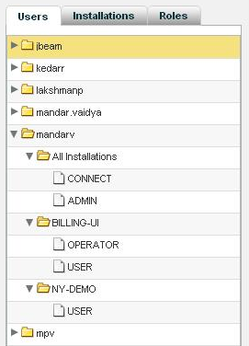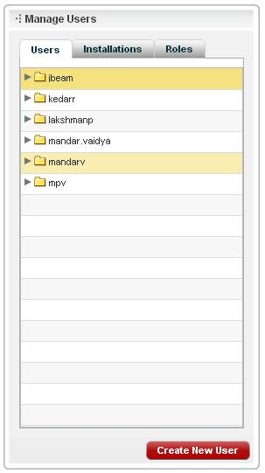

Figure 36 Tree view section in Manage User Screen

As shown above, the users tree view shows, user as parent node. The child node will be installation and its child node will be role. The Installations tree view shows, installation as parent node. The child node will be role and its child node will be user. The Roles tree view shows, role as parent node. The child node will be user and its child node will be installation.

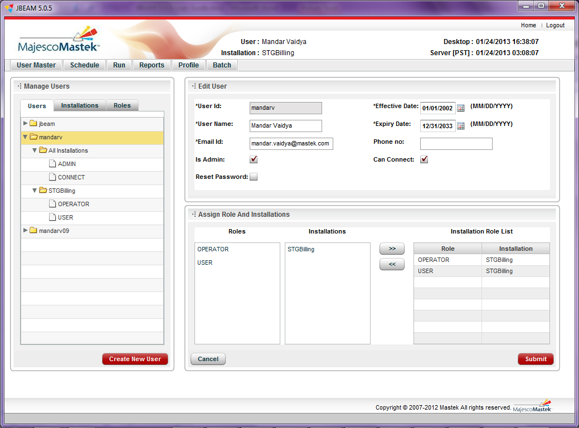

Figure 37 Manage User Screen with a user selected

# Password Management

Change Password

This module facilitates user to change the password. The user id is populated by the system. The required input fields are the old password, new password and confirm new password. Enter valid data and click on ‘Change Password’ button. The ‘Reset’ button clears the input fields.

For New user, it is mandatory to change password. On first login, this screen is displayed by default. It is essential to change password. On successful completion of password change, User Profile screen is displayed.

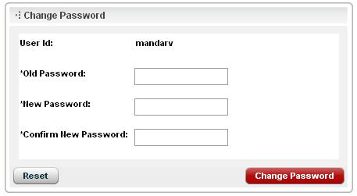

Figure 38 Change Password

Forgot Password

This module facilitates to reset the password in case user forgets the existing. For the same a link is provided on the Login screen just below the button ‘Login’.

To reset the password using ‘Forgot Password’, following are the steps:

1. Choose the server. User needs to choose the appropriate the server for resetting the password. (The desired server has to be configured before this step.)
2. Click on ‘Forgot Password’ link.
3. A window as shown below will open. Follow the steps

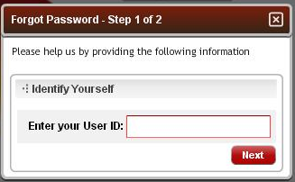

Figure 39 Forgot Password Step -1

1. Enter the user id (case-sensitive) and click on the button ‘Next’.
2. A window as shown below will open.

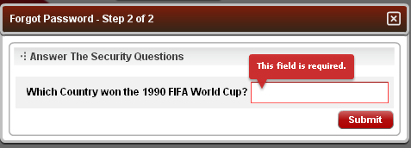

Figure 40 Forgot Password Step -2

1. Enter the answer against the security question that was set upon initial login. It is mandatory and the answer is case sensitive. If the hint question is not set while updating the user profile due to any reason, the system will display a message as shown in following window

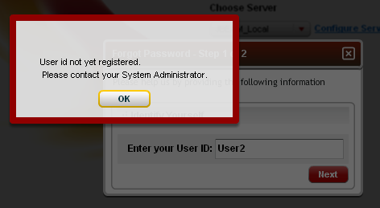

Figure 41 Alert message if the security question is not set

1. On successful security check following message will be displayed.

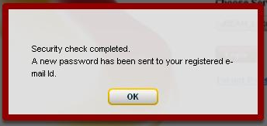

Figure 42 Alert Message Window

# User Profile

This module facilitates to modify the profile.

Here the profile can be updated except the user id. The ADMIN for the server creates user and an email is sent out with a random password. On initial login, it is essential to update the profile.

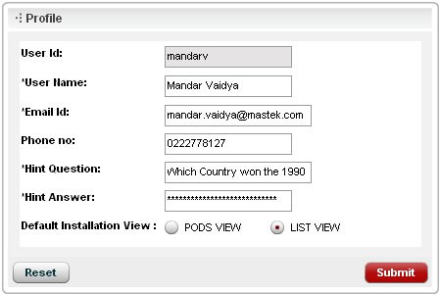

Figure 43 User Profile Panel

Following fields can be updated

* User name
* Email id
* Phone no. (Optional)
* Hint Question

This question has to be set for security check. This is most useful while resting the password whenever needed.

* Hint Answer

This answer completes the security check. This is case-sensitive. It is stored in database in encoded format.

* Default Installation View

There are two views for home screen (POD VIEW / LIST VIEW). Set a view of his/ her choice. The default view set while creating the user is POD VIEW.

# References

# Glossary of Terms

# Business Cycle

# TEMPLATE AMENDMENT HISTORY

|  |  |  |  |  |
| --- | --- | --- | --- | --- |
| Version Number | Date  (dd/mm/yyyy) | Prepared By /  Modified By | Nature of Changes | Reviewed By /  Approved By |
| **0.1** | 13/02/2010 | Anil Shelar | Initial Draft |  |